K8sTask-03

Kubernetes-Services_ReplicationController_and_ReplicaSet

- Create a ClusterIP service for an Apache web server pod.
Step 1 — Create Apache Pod
vi apache-pod.yaml
Add:
apiVersion: v1
kind: Pod
metadata:
name: apache-pod
labels:
app: apache
spec:
containers:
- name: apache
image: httpd
ports:
- containerPort: 80
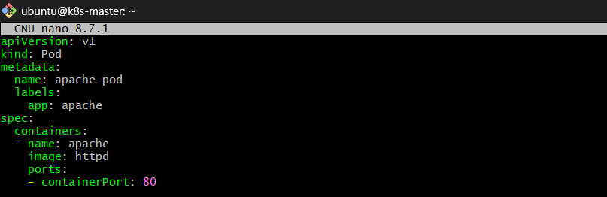
Create the Pod:
kubectl apply -f apache-pod.yaml 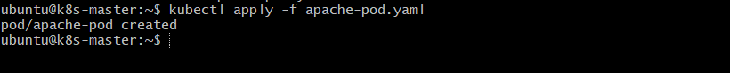

Verify:
kubectl get pods 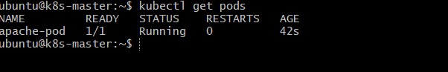

Step 2 — Create ClusterIP Service
vi apache-service.yaml
Add:
apiVersion: v1
kind: Service
metadata:
name: apache-service
spec:
type: ClusterIP
selector:
app: apache
ports:
- port: 80
targetPort: 80 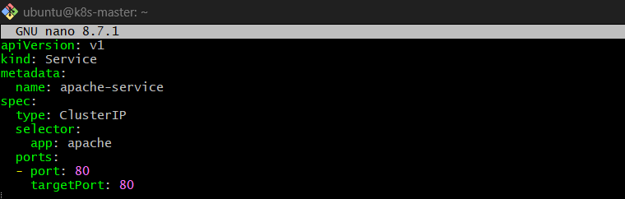
Create the Service:
kubectl apply -f apache-service.yaml 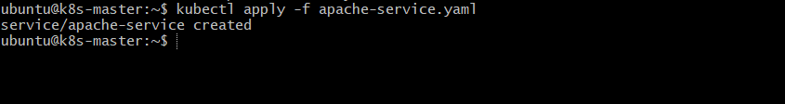

Step 3 — Verify Service
kubectl get svc
You should see:
NAME TYPE CLUSTER-IP PORT(S)
apache-service ClusterIP 10.x.x.x 80/TCP
Check endpoints:
kubectl get endpoints apache-service
The endpoint should show the Apache Pod IP:80.
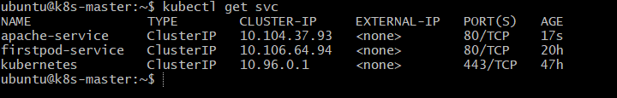
How it works
Client Pod
|
| apache-service:80
↓
ClusterIP Service
|
↓
Apache Pod :80
Important: ClusterIP is accessible only inside the Kubernetes cluster.

- Expose an Nginx pod externally using a NodePort service.
Step 1 — Create Nginx Pod
vi nginx-pod.yaml
Add:
apiVersion: v1
kind: Pod
metadata:
name: nginx-pod
labels:
app: nginx
spec:
containers:
- name: nginx
image: nginx
ports:
- containerPort: 80
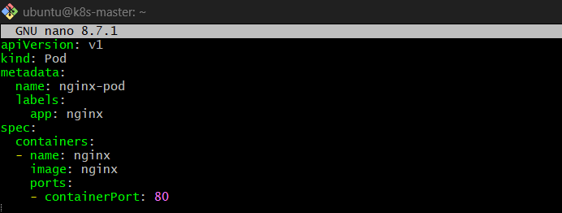

Create the Pod:
kubectl apply -f nginx-pod.yaml 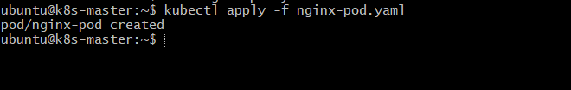
Verify:
kubectl get pods 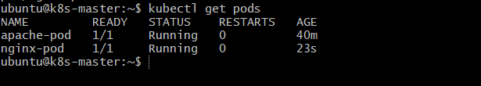

Step 2 — Create NodePort Service
vi nginx-service.yaml
Add:
apiVersion: v1
kind: Service
metadata:
name: nginx-service
spec:
type: NodePort
selector:
app: nginx
ports:
- port: 80
targetPort: 80
nodePort: 30080
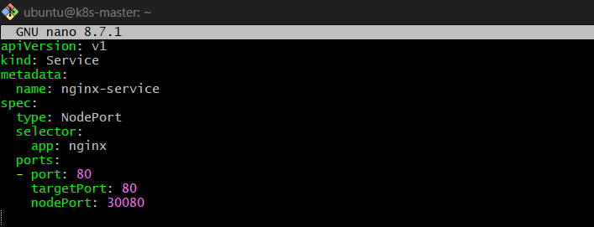
Create the Service:
kubectl apply -f nginx-service.yaml 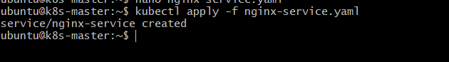

Step 3 — Verify
kubectl get svc
You should see:
NAME TYPE CLUSTER-IP PORT(S)
nginx-service NodePort 10.x.x.x 80:30080/TCP
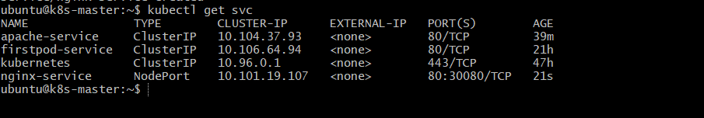
Check endpoints:
kubectl get endpoints nginx-service 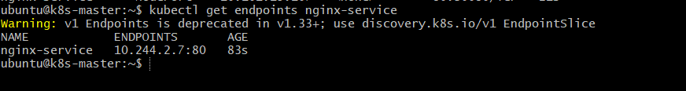

Step 4 — Access Nginx Externally
Get the node IP:
kubectl get nodes -o wide
Then open:
http://<Node-Public-IP>:30080
Example:
http://13.234.xx.xx:30080 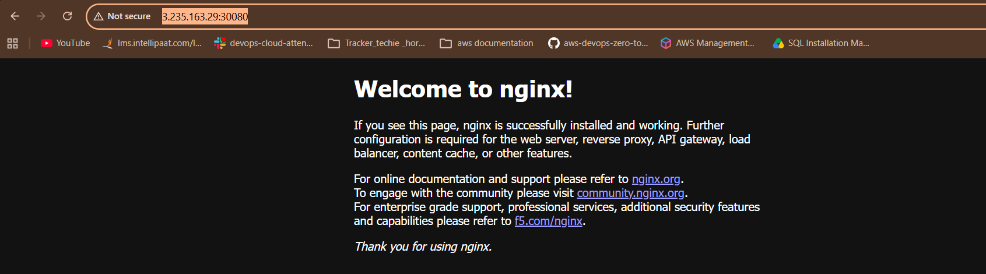
How it works
Browser
|
| NodeIP:30080
↓
NodePort Service
|
| targetPort 80
↓
Nginx Pod :80
Key point: 30080 is the external NodePort, while Nginx is running on port 80 inside the Pod.

- Deploy a ReplicationController to maintain 3 replicas of an Nginx pod.
Step 1 — Create ReplicationController
nano nginx-rc.yaml
Add:
apiVersion: v1
kind: ReplicationController

metadata:
name: nginx-rc

spec:
replicas: 3

selector:
app: nginx

template:
metadata:
labels:
app: nginx

spec:
containers:
- name: nginx
image: nginx
ports:
- containerPort: 80
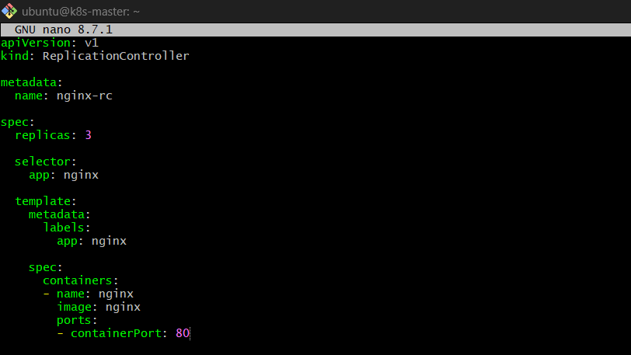
Step 2 — Create the ReplicationController
kubectl apply -f nginx-rc.yaml 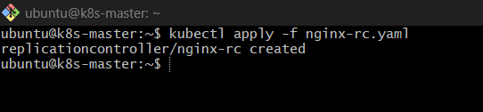
Step 3 — Verify
kubectl get rc
You should see:
NAME DESIRED CURRENT READY
nginx-rc 3 3 3
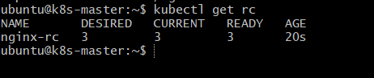
Check Pods:
kubectl get pods 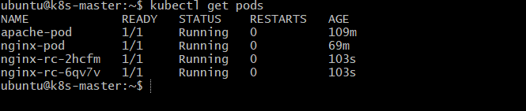
You should see 3 Nginx Pods:
nginx-rc-xxxxx Running
nginx-rc-yyyyy Running
nginx-rc-zzzzz Running
Step 4 — Test Replication
Delete one Pod:
kubectl delete pod <pod-name>
Then:
kubectl get pods
You will see Kubernetes automatically create a new Nginx Pod.
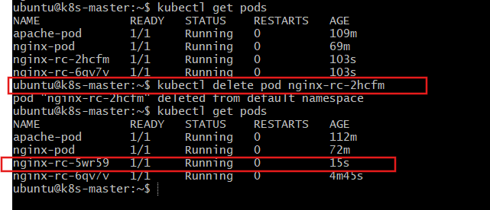

- Scale the ReplicationController from 3 replicas to 5 replicas.
Step 1 — Check current replicas
kubectl get rc
You should see:
NAME DESIRED CURRENT READY
nginx-rc 3 3 3 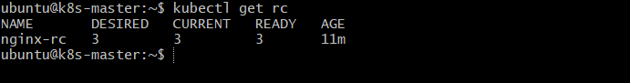
Step 2 — Scale to 5 replicas
kubectl scale rc nginx-rc --replicas=5 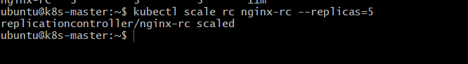
Step 3 — Verify
kubectl get rc
You should see:
NAME DESIRED CURRENT READY
nginx-rc 5 5 5 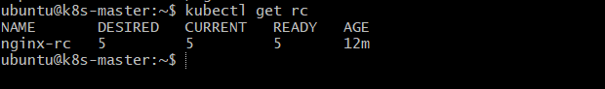
Check Pods:
kubectl get pods
You should now have 5 Nginx Pods.
How it works
Before:
nginx-rc
↓
3 Pods
After:
nginx-rc
↓
5 Pods
The ReplicationController creates 2 additional Pods to reach the desired count of 5.

- Create a ReplicaSet to manage pods based on multiple labels (prod and test).
Step 1 — Create ReplicaSet
nano nginx-rs.yaml
Add:
apiVersion: apps/v1
kind: ReplicaSet

metadata:
name: nginx-rs

spec:
replicas: 3

selector:
matchLabels:
app: nginx
env: prod

template:
metadata:
labels:
app: nginx
env: prod

spec:
containers:
- name: nginx
image: nginx
ports:
- containerPort: 80
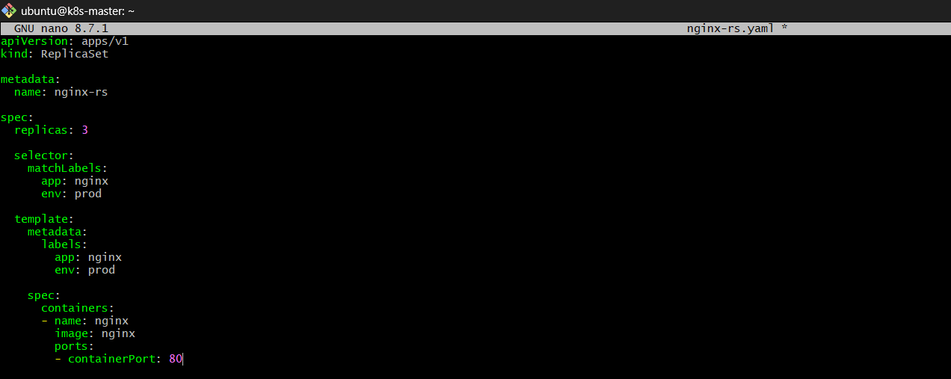
Step 2 — Create ReplicaSet
kubectl apply -f nginx-rs.yaml 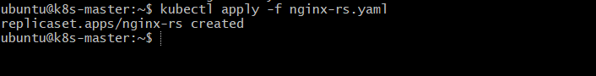
Step 3 — Verify
kubectl get rs
Expected:
NAME DESIRED CURRENT READY
nginx-rs 3 3 3
Check Pods:
kubectl get pods --show-labels
You should see 3 Pods with:
app=nginx,env=prod
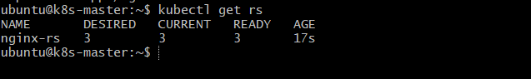
Step 4 — Check only prod Pods
kubectl get pods -l app=nginx,env=prod
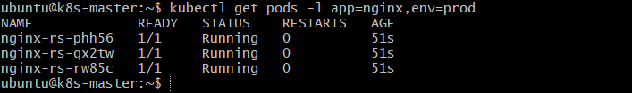
What about test?
Create a Pod with:
labels:
app: nginx
env: test
This Pod will NOT be managed by this ReplicaSet, because the ReplicaSet requires:
app=nginx AND env=prod
Simple example
ReplicaSet selector:
app = nginx
env = prod

↓

app=nginx, env=prod ✅ Managed
app=nginx, env=test ❌ Not managed
app=apache, env=prod ❌ Not managed
Key point: Multiple labels in matchLabels use AND logic, not OR.

- Deploy a ReplicaSet that excludes pods with the label backend.
Purpose
The purpose of this task is to learn how a ReplicaSet can select specific Pods based on labels and exclude Pods that have a particular label.
For example:
backend=true → ❌ Exclude
backend absent → ✅ Manage
We can use matchExpressions with DoesNotExist.

Step 1 — Create ReplicaSet YAML
nano nginx-rs-exclude.yaml
Add:
apiVersion: apps/v1
kind: ReplicaSet

metadata:
name: nginx-rs

spec:
replicas: 3

selector:
matchExpressions:
- key: backend
operator: DoesNotExist

template:
metadata:
labels:
app: nginx

spec:
containers:
- name: nginx
image: nginx
ports:
- containerPort: 80 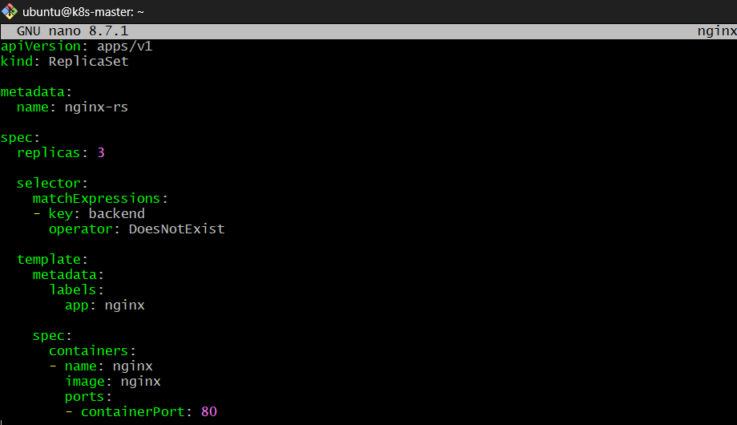

Step 2 — Create ReplicaSet
kubectl apply -f nginx-rs-exclude.yaml 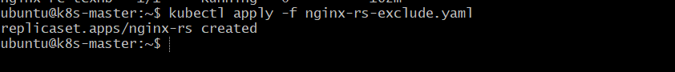
Step 3 — Verify ReplicaSet
kubectl get rs
Expected:
NAME DESIRED CURRENT READY
nginx-rs 3 3 3 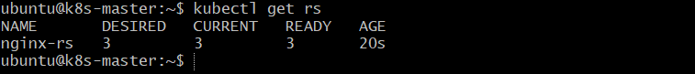
Step 4 — Check Pods and Labels
kubectl get pods --show-labels 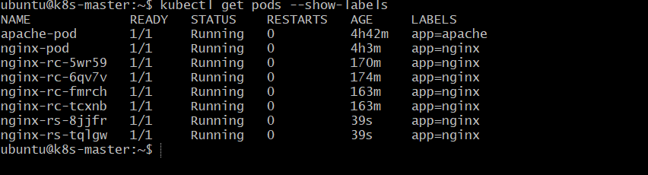
The Pods created by the ReplicaSet will have:
app=nginx
They do not have the backend label.
Step 5 — Create a Pod with backend label
For testing:
nano backend-pod.yaml
Add:
apiVersion: v1
kind: Pod

metadata:
name: backend-pod
labels:
app: nginx
backend: "true"

spec:
containers:
- name: nginx
image: nginx 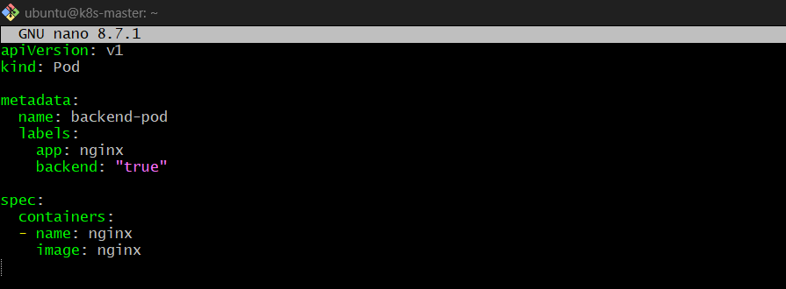
Create it:
kubectl apply -f backend-pod.yaml 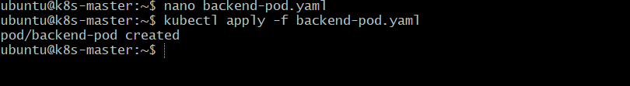
Check:
kubectl get pods --show-labels
You will see:
nginx-rs-xxxxx app=nginx
nginx-rs-yyyyy app=nginx
nginx-rs-zzzzz app=nginx
backend-pod app=nginx,backend=true
The ReplicaSet does not manage backend-pod because it has:
backend=true
How it works
ReplicaSet selector:

backend
|
| DoesNotExist
↓

No backend label → ✅ Managed
backend=true → ❌ Excluded
backend=false → ❌ Excluded
Key point
operator: DoesNotExist
means:
Select Pods where the backend label does not exist.
Note: This is different from backend=false. A Pod with backend=false still has the backend label, so DoesNotExist will exclude it.

- Test load balancing across multiple pods using a NodePort service.
Purpose
To understand how a Kubernetes Service distributes traffic across multiple Pods.
We will create multiple Nginx Pods, expose them using a NodePort Service, and send requests repeatedly to observe that traffic can be distributed across the Pods.

Step 1 — Create 3 Nginx Pods
The easiest way is to use a ReplicaSet.
nano nginx-rs.yaml
Add:
apiVersion: apps/v1
kind: ReplicaSet

metadata:
name: nginx-rs

spec:
replicas: 3

selector:
matchLabels:
app: nginx-lb

template:
metadata:
labels:
app: nginx-lb

spec:
containers:
- name: nginx
image: nginx
ports:
- containerPort: 80 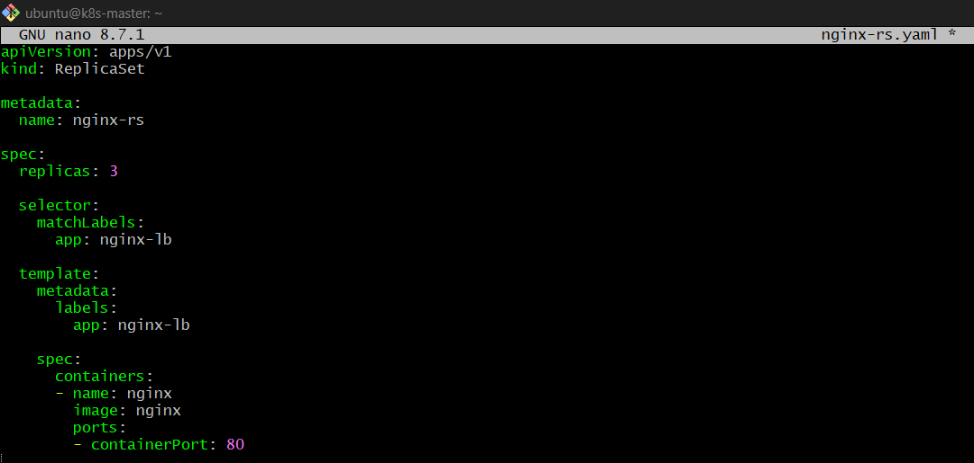

Create it:
kubectl apply -f nginx-rs.yaml

Step 2 — Verify Pods
kubectl get pods -l app=nginx-lb -o wide
You should see:
nginx-rs-xxxxx Running 10.244.x.x
nginx-rs-yyyyy Running 10.244.x.x
nginx-rs-zzzzz Running 10.244.x.x
You now have 3 backend Pods.

Step 3 — Create NodePort Service
nano nginx-lb-service.yaml
Add:
apiVersion: v1
kind: Service

metadata:
name: nginx-lb-service

spec:
type: NodePort

selector:
app: nginx-lb

ports:
- port: 80
targetPort: 80
nodePort: 30080
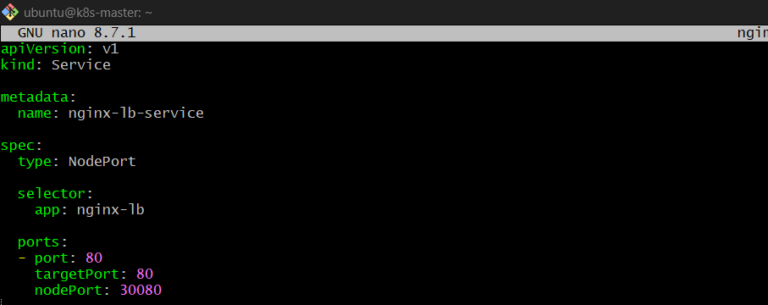
Create it:
kubectl apply -f nginx-lb-service.yaml 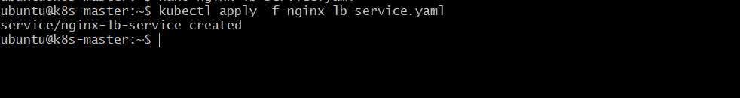

Step 4 — Verify Service
kubectl get svc nginx-lb-service
Expected:
NAME TYPE CLUSTER-IP PORT(S)
nginx-lb-service NodePort 10.x.x.x 80:30080/TCP 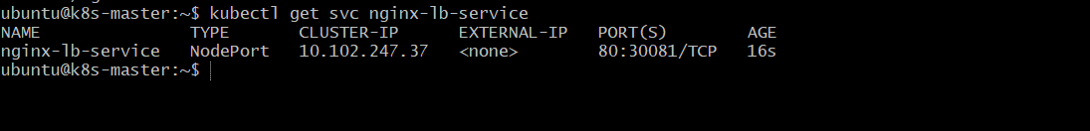

Step 5 — Check Endpoints
kubectl get endpoints nginx-lb-service
You should see 3 Pod IPs:
10.244.1.10:80,10.244.2.11:80,10.244.1.12:80
This confirms the Service knows about all 3 Pods. 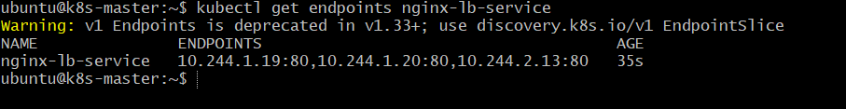

Step 6 — Access from Browser
Get the Worker Node's EC2 Public IP.
For example:
3.235.163.29
Open:
http://3.235.163.29:30080 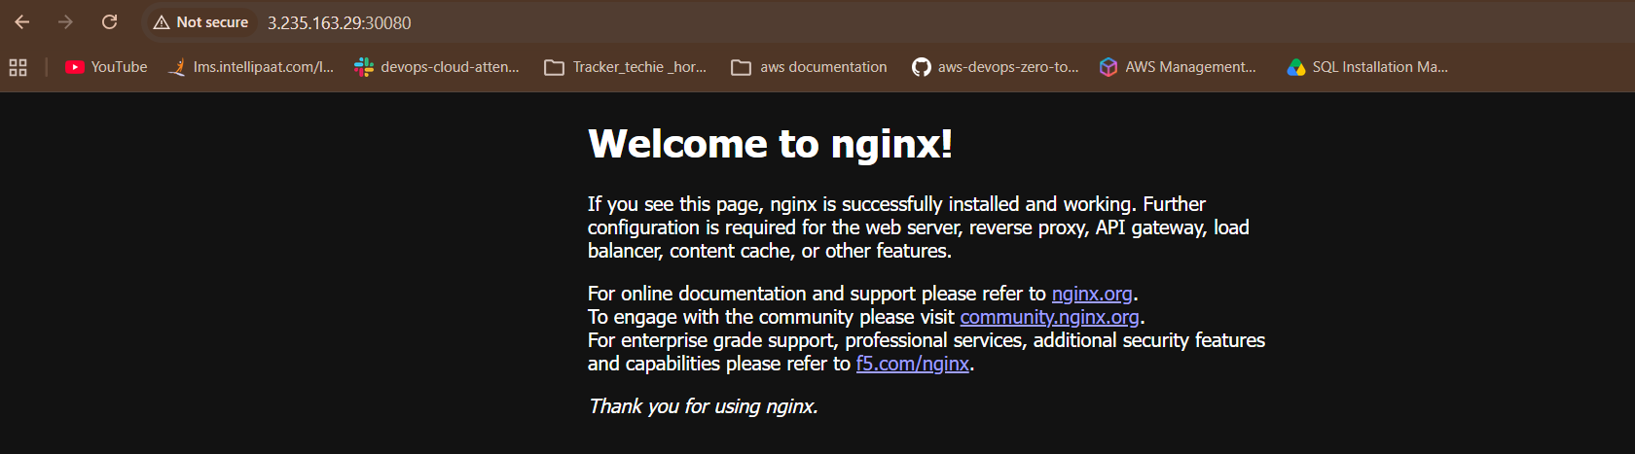
The request goes:
Browser
|
| EC2 Public IP:30080
↓
NodePort
|
↓
nginx-lb-service
|
├──→ Pod 1
├──→ Pod 2
└──→ Pod 3

Step 7 — Test Load Balancing
To clearly see which Pod receives the request, give each Nginx Pod a different response.
For example:
Pod 1 → "NGINX POD 1"
Pod 2 → "NGINX POD 2"
Pod 3 → "NGINX POD 3"
Then send requests repeatedly:
for i in {1..10}; do curl http://3.235.163.29:30080; done
The Service selects one of the available endpoints for each connection/request.
Important
With the default Nginx image, all 3 Pods return the same Nginx welcome page, so you may not visually notice the load balancing.
The important verification is:
kubectl get endpoints nginx-lb-service
which shows the Service has 3 backend Pod endpoints.
Key point
NodePort exposes the Service externally, and the Service distributes traffic to the Pods selected by its selector.
NodePort

- Delete a ReplicationController without affecting the running pods.
Purpose
To learn how to delete a ReplicationController while keeping its Pods running.
Normally, deleting an RC also deletes the Pods it manages. We can prevent this using:
--cascade=orphan
Step 1 — Check the ReplicationController
kubectl get rc
Example:
NAME DESIRED CURRENT READY
nginx-rc 5 5 5 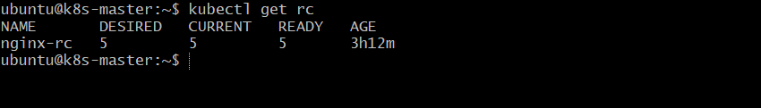
Check its Pods:
kubectl get pods 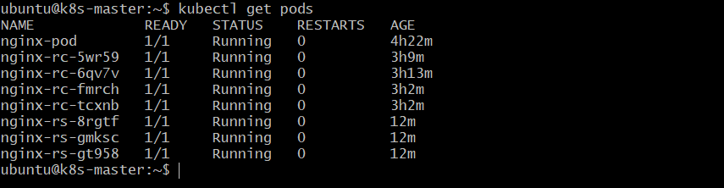
Step 2 — Delete RC but keep Pods
kubectl delete rc nginx-rc --cascade=orphan
Expected:
replicationcontroller "nginx-rc" deleted
Step 3 — Verify RC is deleted
kubectl get rc
nginx-rc should no longer appear.
Step 4 — Verify Pods are still running
kubectl get pods 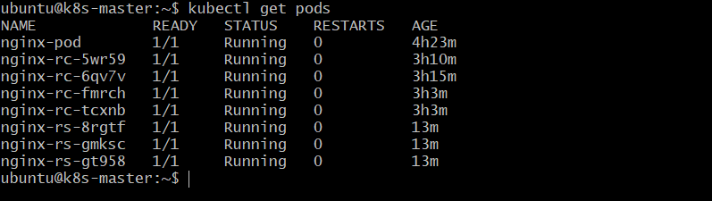
The Pods should still be:
Running
How it works
Before:
ReplicationController
|
├── Pod 1
├── Pod 2
└── Pod 3
Run:
kubectl delete rc nginx-rc --cascade=orphan
After:
ReplicationController ❌ deleted

Pod 1 ✅
Pod 2 ✅
Pod 3 ✅
Key point

